R. Reports Menu: 1. Print License Forms

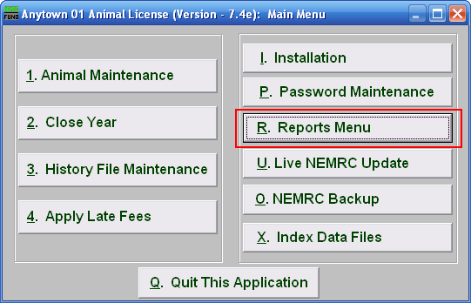
Click on “R. Reports Menu” from the Main Menu and the following window will appear:

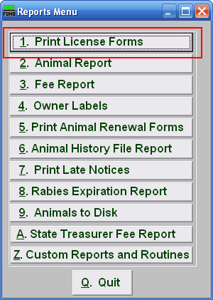
Click on “1. Print License Forms” from the Reports Menu and the following window will appear:

Print License Forms

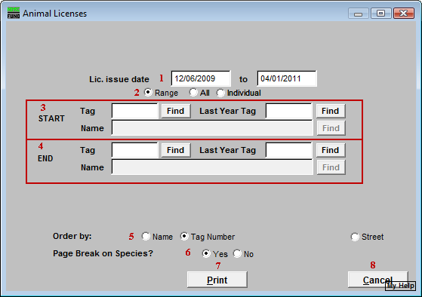
- Lic. Issue date: Enter the licensing period covered that will appear on the printed license.

- Range OR All OR Individual: Choose whether this report will be for a Range of, All, or an Individual animal.

- Start: This is only available if you chose “Range” or “Individual.” Enter the tag number, or last year tag number, of the animal you wish to start with, or click “Find” and select from the Lookup table.

- End: This is only available if you chose “Range.” Enter the tag number, or last year tag number, of the animal you wish to end with, or click “Find” and select from the Lookup table.

- Order by: Select whether the licenses will print in order of owners name, animal tag number, or Street.

- Page Break on Species?: Select if this report will start a new page for each species.

- Print: Click this button to print. Refer to GENERAL PRINTING for more information.

- Cancel: Click “Cancel” to cancel and return to the previous screen.

